**What are Pests?**

Pests are living organisms that are found where they are unwanted or cause damage to crops, humans or other animals.

## **What are Pesticides?**

Pesticides are substances or mixtures of substances intended for preventing, destroying, repelling, or mitigating any pest. They are a range of products used to control pests such as rats and mice, weed, insects, mold or fungi, slugs.

## **Classification of Pesticides**

Pest Pesticide Used

Rats, Mice Rodenticides

Weed Herbicides

Insects Insecticides

Fungi Fungicides

Slugs/Snails Molluscicides

Nematodes Nematicides

The use of Pesticides has affected the following areas of human life: Agriculture, Health.

## 

## **Pesticides of Botanical Origin**

There are two categories of Pesticides, those from botanical/natural sources and the synthetic ones. Pyrethrum is a pesticide from a natural source and several synthetic compounds like Pyrethrum have been developed.

Some of these are fenvalerate and several other pyrethroids (synthetic analogues of Pyrethrin)

Pyrethrum is from the dried flower heads of *Chrysanthemum cinerariaefolium* and cultivated in Kenya, Tanzania, Rwanda, Japan, Eastern Europe, Brazil, and India.

Kenya has an altitude of about 1,900-2,700m and an annual rainfall of 76-180cm. The altitude is important and gives a low night temperature of 5-150C which stimulates bud production.

9% of insecticidal activity are in the flower which are harvested for about 9months in a year. Though the Pyrethrum flowers are not toxic to insects before drying. The closed flower – heads are about 6-9mm in diameter and about 9-12mm in diameter when opened.

Other species used as insecticides include *Chrysanthemum* *coccineum* and *Chrysanthemum marshalli*

## **Characteristics of the Insecticides from the *Chrysanthemum species***

The powder of the *Chrysanthemum* species has parenchyma with aggregate crystals, T shaped hairs, several spherical pollen grains. The Kenya flowers contains not less than 1.3% Pyrethrin, the Japanese has 0.9 – 1.0% and the Dalmatian about 0.7-0.8%.

The insecticidal properties in Pyrethrum are due to the ester products of the oil glands, resin ducts and mesophyll cells.

Pyrethrin I, Jasmolin I, cinerin I are esters of chrysanthemic acid (chrysanthemum monocarboxylic acid).

Pyretrin II, Jasmolin II and Cinerin II are esters of pyrethric acid.

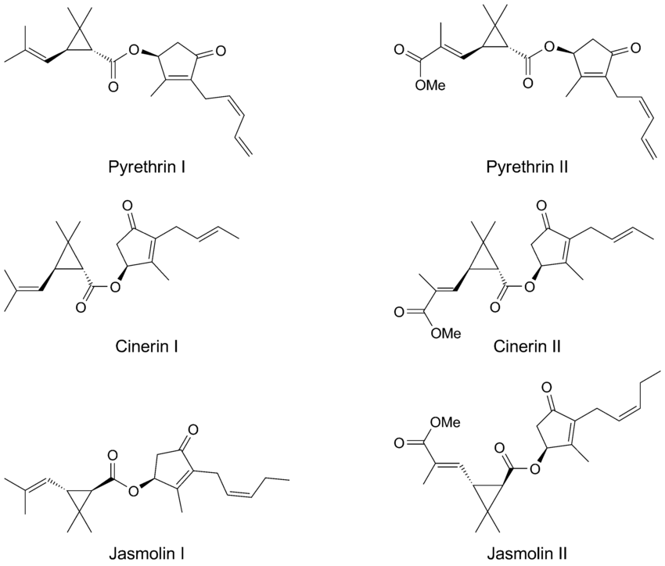

## **Products with Pyrethrum and Pyrethrin**

The pyrethrum extract is used in the preparation of dusting powder and the powder has about 0.36-0.44% pyrethrin, half of which is pyrethrin I. In addition, some of the commonly sold Insecticides have certain percentages of Pyrethrin

## **What is the Effect of Pyrethrum or Pyrethrin of botanical sources on Insects**?

* It exhibits a knock-down action (which is due to pyrethrin II).
* Lethal to insects (Pyrethrin I)

## **Advantages of using Pyrethrum and Pyrethrin Products from Natural Sources**

* They are biodegradable
* They have high potency and selective toxicity
* Ability to reduce disease transmission
* They are cost effective
* They are relatively stable in the environment

## **Side effects of synthetic insecticides**

* Environmental pollution
* Health hazards
* Resistance of insects and pest resurgence

The synthetic analogues of pyrethrum possess higher insecticidal effects (about 1,000 times higher) than that from natural sources, and are more photostable, these characteristics have displaced preference for natural pyrethrin. However, they are still useful in food processing (insecticidal spraying of edible fruits and vegetables shortly before harvesting).

## **Other Botanical Sources of Pesticides**

Dried rhizomes of *Derris elliptica*, *D. malaccensis* and Dried roots of *Lonchocarpus utilis*, *L. urucu*; *Milletia s*pp and *Tephrosia* spp are indigenous to Peru and Brazil.

*Derris spp* and *Lonchocarpus* spp contains about 3-10% rotenone, a colourless crystalline substance which is insoluble in water but soluble in organic solvents. *Nicotiana tabaccum* and other species of *Nicotiana* are sources of insecticides of plant origin. (Nicotine, Nornicotine, anabasine all exhibit insecticidal properties).

*Artemisia argyi* was investigated for its ability to kill the grain insect *Lasioderma serricorne* (cigarette beetle) responsible for destroying insect pests of stored cereals, tobacco, oil seeds, dried fruits. The essential oils present in the plant proved effective against the pest insects. The oil contained eucalyptol, B-pinene, B-caryophyllene, camphor, thujone and other compounds.

## Larvicides (Plants with Larvicidal Activities)

Larvicides are insecticides which eliminate pests before they develop into Adult stage that is, they destroy the larva stage. This is used in the elimination of the larva of the *Anopheles* spp, *Culex pipens*.

## **Examples of Larvicides from the Nigerian Flora**

*Azadirachta indica* (Neem), *Citrus* spp, *Mangifera indica, Cocos nucifera*, *Anacardium occidentale, Ricinus communis*

*Paullina pinnata*, *Buccholzia coriacea* and *Funtumia africana* were all tested against the third and fourth instar larvae of *Anopheles gambiae* and *Culex pipens* respectively.

## **Herbicides**

Herbicides are compounds used to control weeds particularly those who compete with crops for edaphic resources (water, nutrients), space and sunlight. Many weeds are hosts of pathogens which in turn lead to occurrence and spread of plant diseases. Some botanical herbicides include: *Phytophthora palmivora* for the control of stranglervine (*Morrenia odorata)* in *Citrus* Plantations.

## 

## Schistosomiasis

Schistosomiasis (Bilharzia) is an acute and chronic disease of humans caused by parasitic flatworms (trematode worms) called Schistosomes in the Tropical and Subtropical Countries. The freshwater snails act as intermediate hosts for the blood flukes causing the disease.

## **Symptoms of Schistosomiasis**

* Blood in urine (haematuria)
* Abdominal pains
* Blood in the stool
* Diarrhoea
* Rash
* Itchy skin
* Chills
* Cough
* Headache
* Stomach pain
* Joint pains
* Muscle aches

This disease causes intestinal and bladder damage. When people suffering from Schistosomiasis contaminate fresh water sources with excreta and urine containing the parasite eggs, these hatch to miracida in the water which then locates the freshwater snail and develops into sporocyst, these sporocyst grow and are then released by the snail as cercaria. These larva form of the parasite infects humans when released by the freshwater snails by penetrating the human skin during wading in infested water. They then shed their forked tail to form a schistosomula. In the human body the larva develops into adult schistosome which lives in the blood vessels where the female releases eggs and are passed out of the body in the faeces and urine to continue the life cycle. A few others remain in the human body causing damages to the intestines and bladder.

*Schistosoma mansoni*, *Schistosoma haematobium* are prevalent in Africa others are *Schistosoma japonicum, Schistosoma mekongi.*

*S. haematobium* infects snails of the genus *Bulinus*. *S. japonicum* infects snails of the genus *Oncomelania*. *S. mekongi* infects snails of the genus *Neutricula* while, *S. mansoni* infects snails of the genus *Biomphalaria*

A means of preventing Schistosomiasis is by eliminating the snail hosts. One of the ways this can be achieved is by using pesticides known as Molluscicides for this purpose.

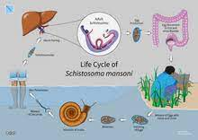

**Life cycle of *S. haemotobium, S. mansoni* and *S. Japonicum***

## **What are Molluscicides?**

Molluscicides are pesticides used to eliminate slugs and snails that are responsible for destruction of food plants and who act as agents for disease-causing organisms. There are two types of Molluscicides: Synthetic and Natural Molluscicides.

## **Molluscicides of Plant Origin**

Members of the families Leguminosae, Araliaceae, Asteraceae and Liliaceae have been identified as main sources of Molluscicides.

Molluscicide of plant origin are preferred because:

* They are ecologically friendly
* Biodegradable
* Culturally acceptable
* Readily available
* Cheaper
* Less polluting than the synthetics
* A self-reliant control strategy

The active secondary metabolites found to exhibit these Molluscicidal effects are mainly saponins the effect or activities of these saponins vary with the position of their glycosidic chain, the nature of the sugar chains, the sequence of the sugars, the interglycosidic linkages and substitution patterns of the aglycone.

One of such plants is the Ethiopian plant (the soap berry) *Phytolacea dodecandra* which is effective in the waterways of snails. Another of such plant is *Swartzia madagascariensis* (Leguminosae) found throughout Africa exhibits folklore medicinal Molluscicidal and insecticidal uses.

The spirostanol saponins, from *Balanites aegyptiaca* are potent molluscicides. Balanitin 1,2,3 have been isolated from this plant.

Furthermore, linalool from *Cinnamomum camphora* (L) extracts has been used to eliminate *Oncomelania hupensis* snails. Linalool therefore could also be used to treat *S. japonicum* infection.

## **Effect of the molluscicides on the host snails**

* Muscular and spiral twisting of the snail body
* Destruction and cell degeneration
* Shrinking of the hepatopancreas of the snails

Other Plants that have also exhibited Molluscicidal activities include: The aqueous extracts *Thevetia peruviana*, *Alstonia scholaris* and *Euphorbia pulcherrima* as well as the latex of *Euphorbia hirta.*